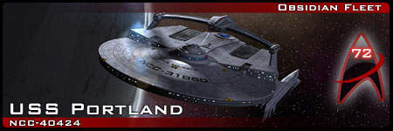

**Application Form**

## Player Information

**Name:**   
**Email:**

**Are you over 13?:** (Note: You MUST answer this question. For legal reasons, you must be over 13 to participate in any Obsidian Fleet simm)

**Other contact info (Skype, facebook, Google+, etc):**

**Previous Simming and Roleplaying Experience:**

## Character Information

**Name:**

**Species:**

**Gender:**

**Age/Date of Birth:** (note – the current year is 2391)

**Position Applied For:**

**Requested Rank (if applicable):** (Note: Starfleet ranks from lowest to highest are Ensign, Lt. Junior Grade, Lt., Lt. Cmdr., Cmdr., Captain. Be realistic, and note that your character’s rank is subject to approval by the command team)

**Physical Description:**

**Personality Traits:**

**History:** (note – the current year is 2391)

## Sample Post

**Write a sample post. You may use any of the following scenarios as inspiration, or come up with your own:**

You are asleep in your quarters, when you are rudely awakened by a loud noise. Quickly, you realize that it is the red alert signal…

You are at the local pub with several other officers. After several glasses of synthale, the lively conversation turns to the academy and why the table’s younger selves decided to join Starfleet. At a break in the conversation, a fellow officer turns to you and asks “So, (character), why did you join up?”

Finally! For the first time in a few weeks, you’re able to get away from your busy schedule and enjoy some well-deserved holodeck time. Entering the holodeck, you activate your favourite program…